**Section 10.7 Problem 4**

Solve the wave equation with initial value f(x), initial velocity 0, where f(x)=1 if L/2-1<x<L/2+1 and 0 otherwise. Here, we take L=10, a=1.

syms x k n t

First we calculate the Fourier sine coefficients of f.

b = @(k) 2*int(sin(k*pi*x/10),x,4,6)/10;

The nth partial sum of the solution is

u = @(x,t,n) symsum(b(k)*sin(k*pi*x/10)*cos(k*pi*t/10),k,1,n);

Here are some plots of the solution u(x,t) versus x for some fixed values of t (taking 100 terms in the series for u).

ezplot(u(x,0,100),[0,10])

title('t=0')

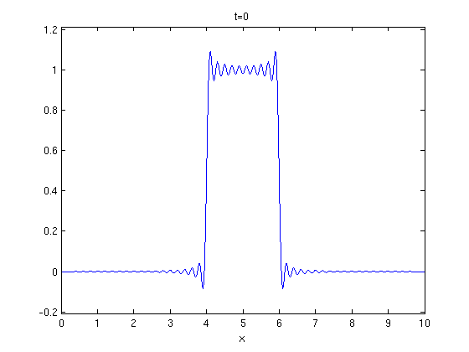

ezplot(u(x,5,100),[0,10])

title('t=5')

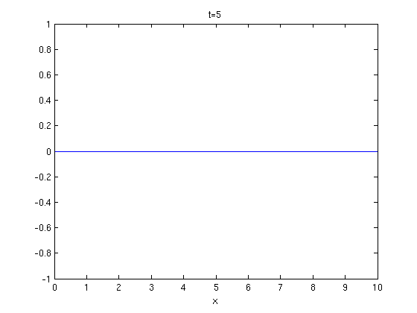

ezplot(u(x,10,100),[0,10])

title('t=10')

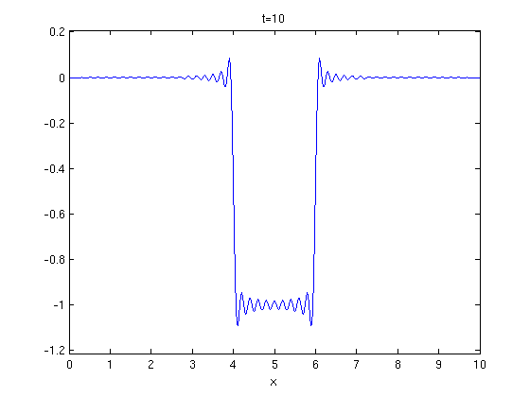

Here are some plots of u(x,t) versus t for some fixed values of x.

T = 0:0.01:20;

U = inline(vectorize(u(5,t,100)));

plot(T,U(T))

title('x=5')

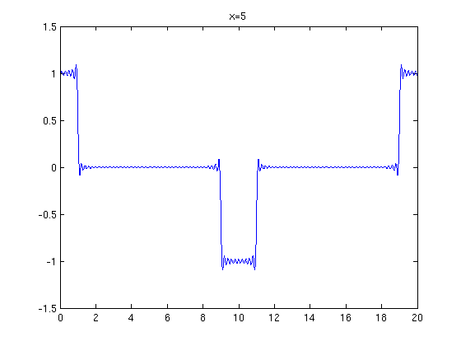

ezplot(u(10,t,100),[0,20])

title('x=10')

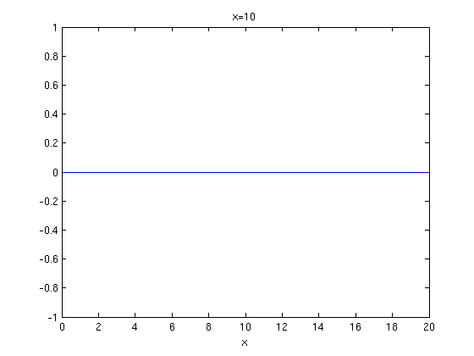

Here is a movie of the motion of the string.

X = 0:0.01:20;

for n = 0:100

U = inline(vectorize(u(x,n,100)));

plot(X, U(X)), axis([0,10,-1.5,1.5]);

M(n+1) = getframe;

end

mplay(M)

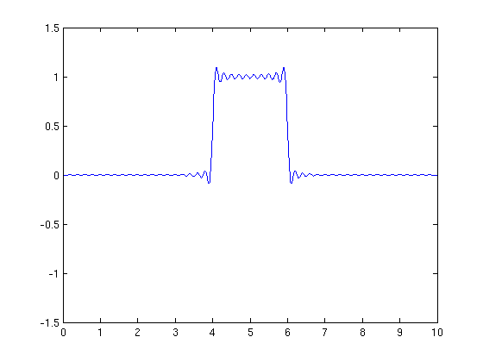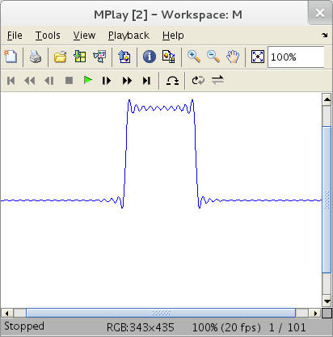

Published with MATLAB® 7.13